Workshop Resources

No Man Left Behind — A model for a thriving disciple-making ministry for every man in your church.
Registration and Info
Registration fee includes:
Lunch, plus the resource book No Man Left Behind, Man Talk Cards and workshop materials.

Contact & Questions:
Bob Bender (631) 281-4892
luthermanmnys@gmail.com

Building Men for Christ
WORKSHOP

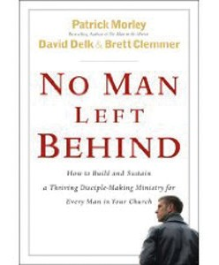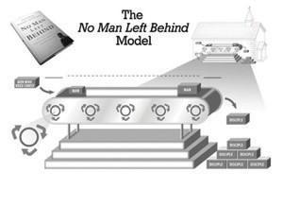Workshop Presenter:
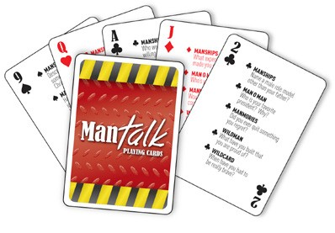
Man Talk Cards A one day

workshop to
help church leaders

WORKSHOP TOPICS INCLUDE:
Value of Relationships Understanding How Guys Differ
The No Man Left Behind Model Overview I-GO Strategy
Identify - Invite - Invest Capturing/Sustaining Momentum Strategies Activity Planning Strategies
Resource Demonstrations
...and much more!!
Rich White
President
Lutheran Men in Mission rwhite743@aol.com

develop a life-changing
men’s ministry for their congregation.

Saturday, Nov 12, 2016
8:30 am to 4:30 pm

Ascension Lutheran Church 33 Bay Shore Road Deer Park, NY 11729

Ascension Lutheran Church Deer Park, NY

Building Men for Christ
WORKSHOP

Workshop Schedule

SATURDAY, NOV 12, 2016

8:30 am
Registration and gathering time

9:00 am
- Welcome, opening prayers and introductions
- Call to action
- Relationships
- The Buddy System and The Search to Belong
- I-GO Strategy
- Man Talk Cards Demo
- Break

10:30 am
- How Guys Differ
- Faith Formation 20/20
- No Man Left Behind Model
- Discipleship, Grace & The Man Code

12:00-12:45 pm — Lunch

12:45 pm
- Lutheran Men in Mission Resources & Events

Registration Information

Ascension Lutheran Church 33 Bay Shore Road
Deer Park, NY 11729

Event date: Saturday, Nov 12, 2016

Registration deadline: Nov 1, 2016

Registration fee schedule:
$20 to register (refunded to you the day of the event ) This event is made possible in part through a Leadership Development Grant through the Metropolitan New York Synod’s Strategic Plan

You register to attend!! To register, call or email: Bob Bender
220 W. End Ave. Shirley, NY 11967
(631) 281-4892
luthermanmnys@gmail.com

Make check payable to:
Lutheran Men in Mission

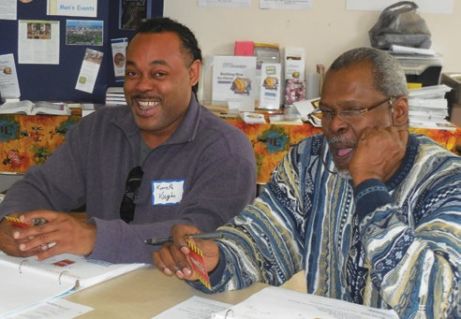
- Master Builder Bible for Men - Small Group Study

- 3 Strands of Leadership
- Break

2:45 pm
Name

Address

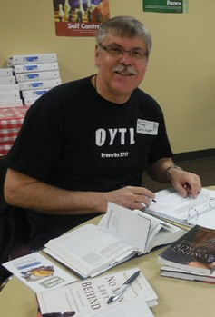
- Create, Capture & Sustain

- Activity / Event Planning
- Reaching Guys in the 4 Quadrants

4:00 pm
- Wrap-up - Key Points & Next Steps
- Commissioning & Sending
City, State, Zip

Phone

Email

Congregation

