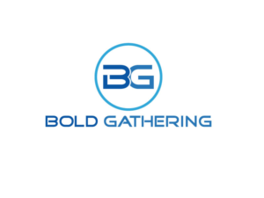
Metro New York Synod Chapter

Annual Meeting

March 18, 2017
9am – Noon
Doors open at 8:30 with a Continental Breakfast

Prince of Peace Lutheran Church
225-17 115th Avenue
Cambria Heights, NY

Guest Speakers
Rev. Lamont Wells, Dir of Evangelical Mission/Assistant to the Bishop
Mr. Kevin Burke, Discipling Consultant of Lutheran Men in Mission
Invited Guest, MNYS Lutheran Youth Organization
Pastor John Krahn, Author of “Surviving to Thriving”
Rev Brenda Irving, Homilest

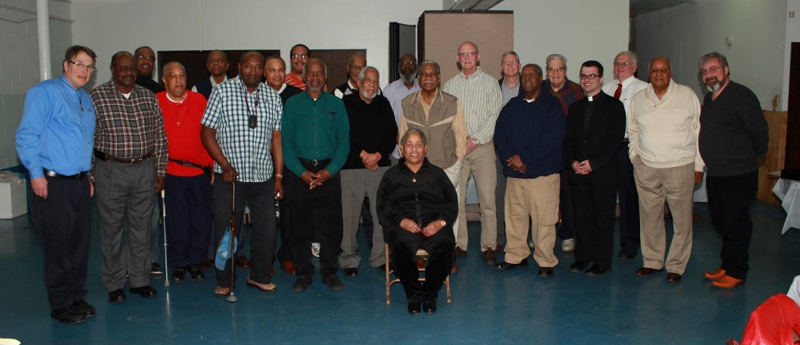
Official business of the chapter and elections
Leadership and Member ship opportunities
Free will offering to cover cost of this event

For more Information:

Bob Bender, President LMM-MNYS
631-281-4892
luthermanmnys@gmail.com

