HOLY COMMUNION: FOR THIS SEASON OF DISCERNMENT
AS WE APPROACH THE ELECTION OF A NEW BISHOP METROPOLITAN NEW YORK SYNOD 2019

GATHERING
GATHERING CONVERSATION

You may wish to begin your gathering time by reviewing the Bishop’s Election Process and Timeline approved by our Synod Council, stating that prayerful, worshipful experiences and conversations undergird and guide this whole process.
It should be emphasized that this is a season for vocational and missional discernment, not a time for campaigning for an election. Participants may also be introduced to the Report from our Town Hall Meetings in the Autumn of 2018 as a way of gathering hearts and minds for this occasion:

Invite participants into a period of quiet reflection on the following questions:
  - What’s on your hearts and minds concerning our life together as a Synod which you bring to this occasion?
  - What are your hopes and dreams for our life together?
  - What are your concerns?
  - What charisms or gifts would a new bishop need to lead our Synod into its future?

Invite participants to prayerfully respond briefly, naming in a word or two their reflections, hopes and concerns.

A leader draws this segment to a close with an extemporaneous prayer that seeks to lay all that has been expressed at the foot of the cross and the portal of the empty tomb.

LITANY FOR THE INVOCATION OF THE HOLY SPIRIT
Come, Holy Spirit!

Come, Holy Spirit!
Come, breath of God and fill the minds and hearts of your people.

Come, Holy Spirit!
Come, fire of truth and kindle in us the flame of your love.

Come, Holy Spirit!
Come, font of wisdom, enlighten us and give us counsel and insight.
Come, Holy Spirit! Come, claim us as your own. Come, Holy Spirit!
Come, gather us to together in Word and Sacrament.

Come, Holy Spirit!
Come, send us for the sake of the world.
Come, Holy Spirit! Come, lead our discerning. Come, Holy Spirit!
Come, guide us into all truth as you have promised.

Come, Holy Spirit!
Come, accompany us during this time of waiting and anticipation.

Come, Holy Spirit!
Come, bless our holy conversations.

Come, Holy Spirit!
Come, inspire those discerning a call to the office of Bishop.

Come, Holy Spirit!
Come, give wisdom to those who will serve as voting members to our Synod Assembly.

Come, Holy Spirit!
Come, deepen our unity as your people in your church.

Come, Holy Spirit!
Come, focus our minds and hearts on our vision for your mission.

Come, Holy Spirit!
Come, embolden our witness for the sake of the world.

Come, Holy Spirit!
Come, strengthen our trust in your promised future.

Come, Holy Spirit!

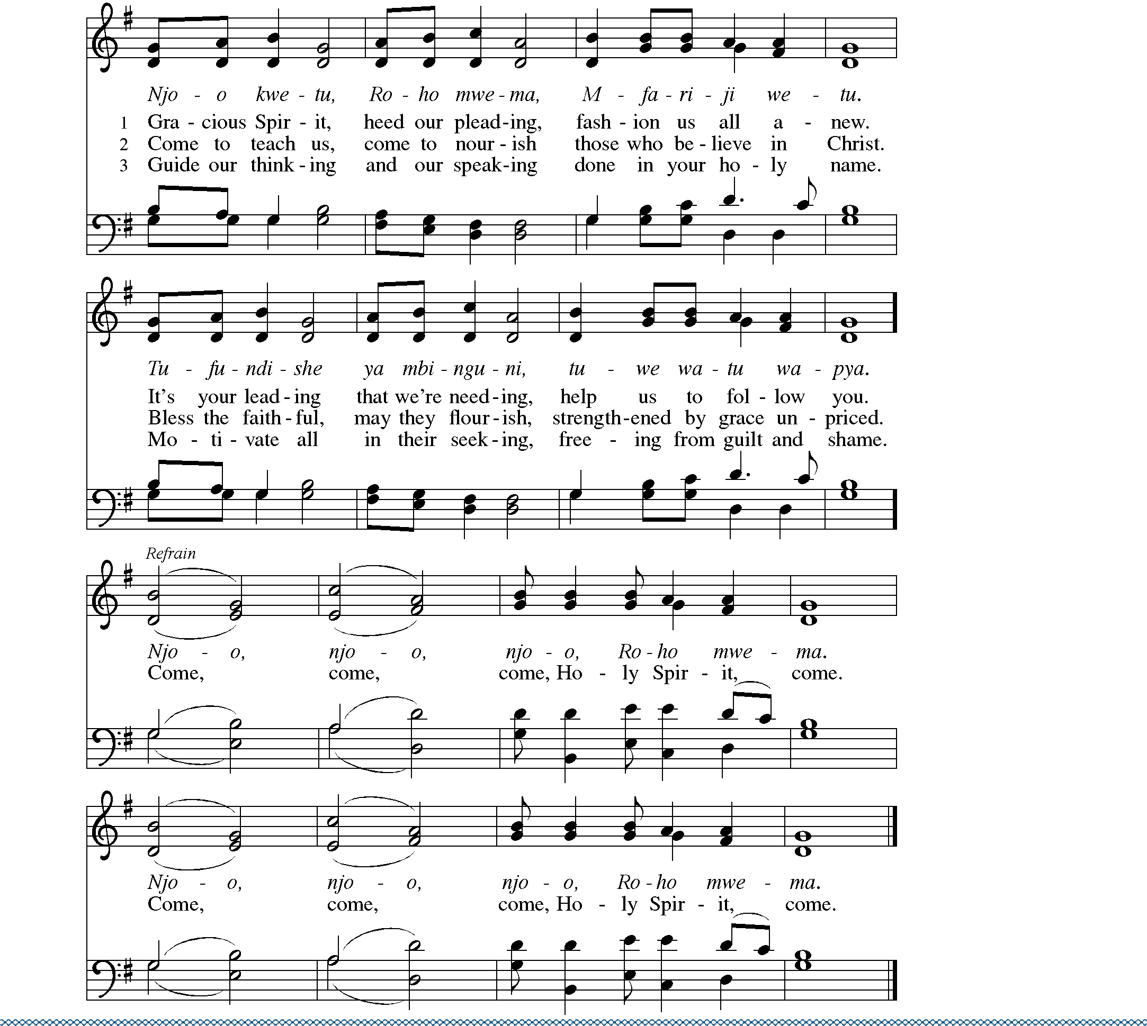Other petitions may be added.
Come, Holy Spirit!
Come, Holy Spirit!

Come, Holy Spirit! Amen.
GATHERING SONG

4

GREETING
The grace of our Lord Jesus Christ, the love of God, and the communion of the Holy Spirit be with you all. And also with you.

PRAYER OF THE DAY
Let us pray.

Almighty God, you have given your Holy Spirit to the church to guide us into all truth. Bless with the Spirit’s grace and presence the people of the Metropolitan New York Synod as we prepare to elect a bishop. Keep us steadfast in faith and united
in love, that we may manifest your glory and prepare for the way of your kingdom; through Jesus Christ, our Savior and Lord. Amen.
WORD

FIRST READING  ISAIAH 6:1-8
A Reading from Isaiah.

In the year that King Uzziah died, I saw the Lord sitting on a throne, high and lofty; and the hem of his robe filled the temple. Seraphs were in attendance above him; each had six wings: with two they covered their faces, and with two they covered their feet, and with two they flew. And one called to another and said: “Holy, holy, holy is the LORD of hosts; the whole earth is full of his glory.” The pivots on the thresholds shook at the voices of those who called, and the house filled with smoke. And I said: “Woe is me! I am lost, for I am a man of unclean lips, and I live among a people of unclean lips; yet my eyes have seen the King, the LORD of hosts!” Then one of the seraphs flew to me, holding a live coal that had been taken from the altar with a pair of tongs. The seraph touched my mouth with it and said: “Now that this has touched your lips, your guilt has departed and your sin is blotted out.” Then I heard the voice of the Lord saying, “Whom shall I send, and who will go for us?” And I said, “Here am I; send me!”

Word of God, word of life. Thanks be to God.

PSALM  PSALM 139:1-18, 23-24

Spoken responsively by whole verse

LORD, you have searched me out; O LORD, you have known me.

You know my sitting down and my rising up; you discern my thoughts from afar.
You trace my journeys and my resting-places and are acquainted with all my ways.
Indeed, there is not a word on my lips, but you, O LORD, know it altogether. You encompass me, behind and before,
and lay your hand upon me.

Such knowledge is too wonderful for me; it is so high that I cannot attain to it.
Where can I go then from your Spirit? Where can I flee from your presence?

If I climb up to heaven, you are there;
if I make the grave my bed, you are there also.
If I take the wings of the morning
and dwell in the uttermost parts of the sea, even there your hand will lead me and your right hand hold me fast.
If I say, “Surely the darkness will cover me, and the light around me turn to night,”

darkness is not dark to you; the night is as bright as the day; darkness and light to you are both alike.
For you yourself created my inmost parts; you knit me together in my mother’s womb.

I will thank you because I am marvelously made; your works are wonderful, and I know it well.
My body was not hidden from you,
while I was being made in secret and woven in the depths of the earth.

Your eyes beheld my limbs, yet unfinished in the womb; all of them were written in your book;
my days were fashioned before they came to be.

How deep I find your thoughts, O God! How great is the sum of them!

If I were to count them, they would be more in number than the sand; to count them all, my life span would need to be like yours.
Search me out, O God, and know my heart; try me and know my restless thoughts.

Look well whether there be any wickedness in me and lead me in the way that is everlasting.

SECOND READING  1 TIMOTHY 3:1-7
A reading from First Timothy.

The saying is sure: whoever aspires to the office of bishop desires a noble task. Now a bishop must be above reproach, married only once, temperate, sensible, respectable, hospitable, an apt teacher, not a drunkard, not violent but gentle, not quarrelsome, and not a lover of money. [They] must manage [their] own household well, keeping children submissive and respectful in every way— for if they do not know how to manage their own household, how can they take care of God’s church? They must not be recent converts, or they may be puffed up with conceit and fall into the condemnation of the devil. Moreover, they must be well thought of by outsiders, so that they may not fall into disgrace and the snare of the devil.

Word of God, word of life. Thanks be to God.

GOSPEL ACCLAMATION
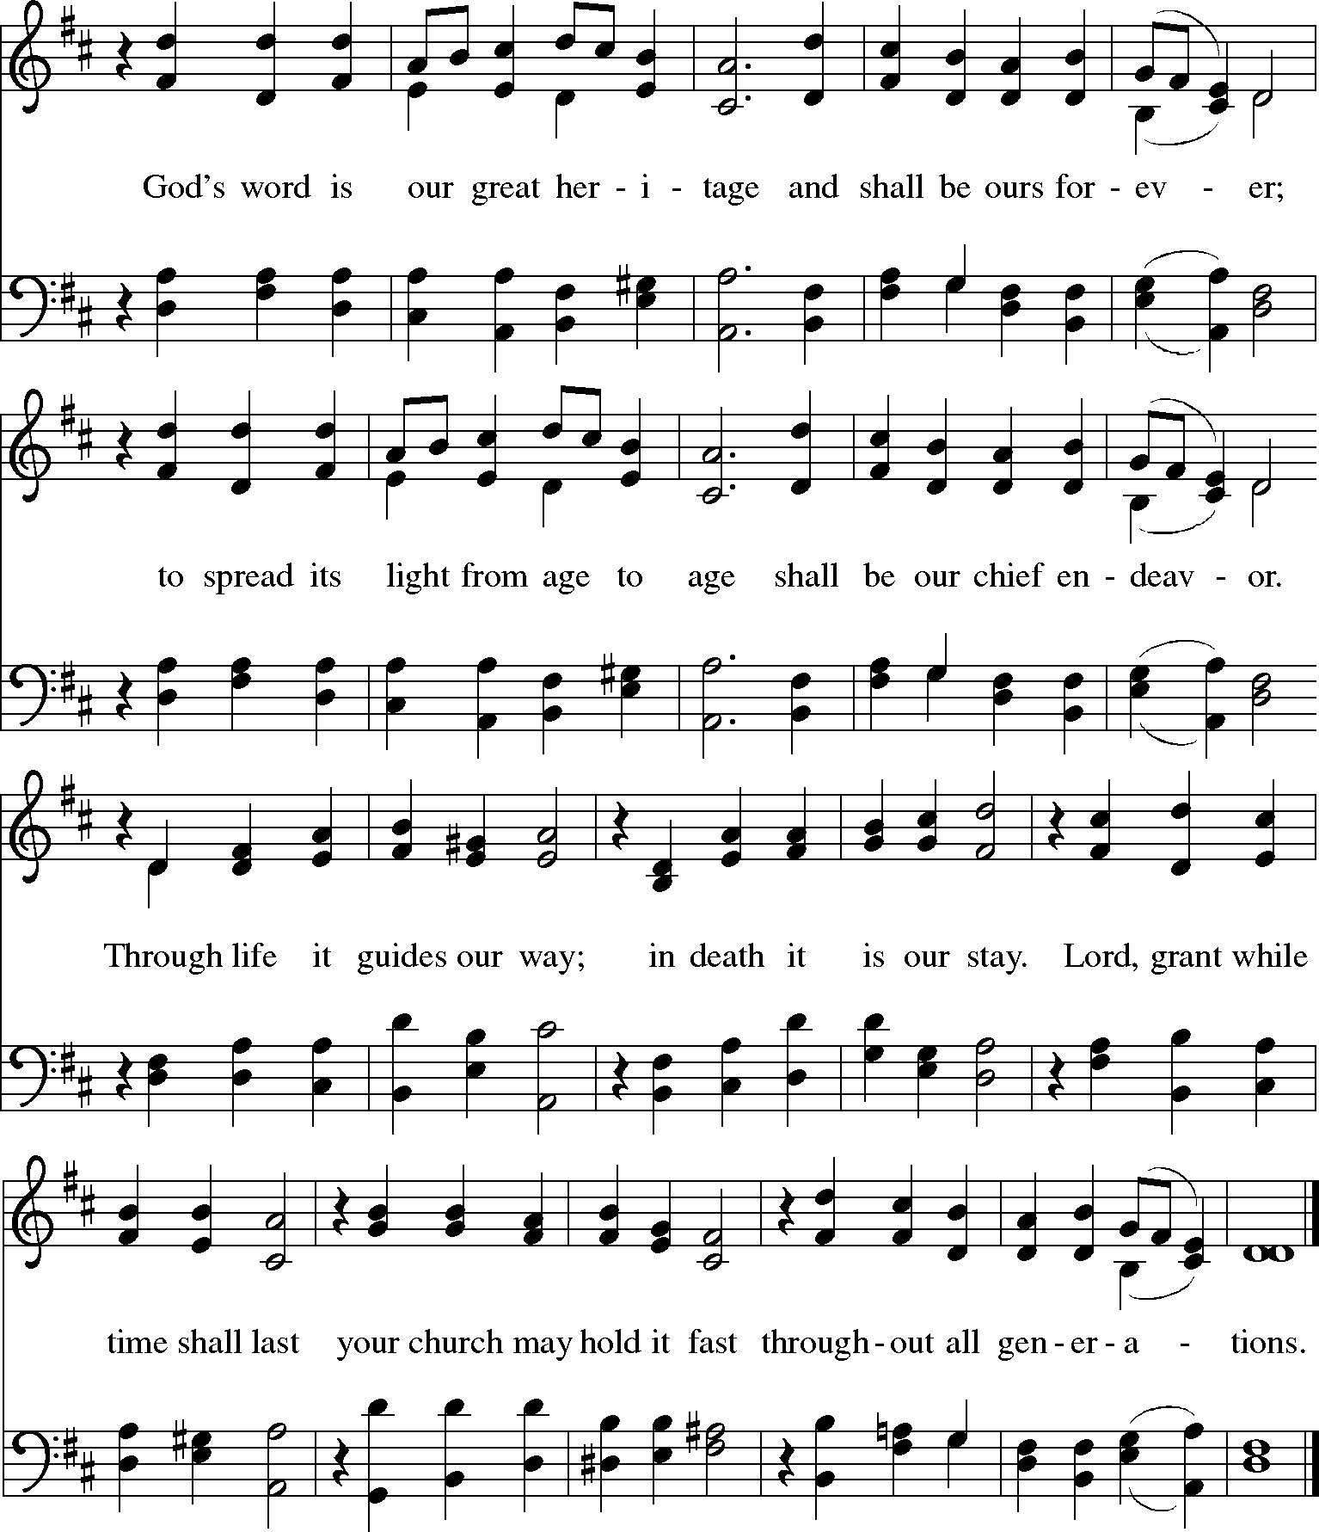

GOSPEL  JOHN 21:15-19
The holy gospel according to John.

Glory to you, O Lord.

When they had finished breakfast, Jesus said to Simon Peter, “Simon son of John, do you love me more than these?” He said to him, “Yes, Lord; you know that I love you.” Jesus said to him, “Feed my lambs.” A second time he said to him, “Simon son of John, do you love me?” He said to him, “Yes, Lord; you know that I love you.” Jesus said to him, “Tend my sheep.” He said to him the third time, “Simon son of John,
do you love me?” Peter felt hurt because he said to him the third time, “Do you love me?” And he said to him, “Lord, you know everything; you know that I love you.” Jesus said to him, “Feed my sheep. Very truly, I tell you, when you were younger, you used to fasten your own belt and to go wherever you wished. But when you grow old, you will stretch out your hands, and someone else will fasten a belt around you and take you where you do not wish to go.” (He said this to indicate the kind of death by which he would glorify God.) After this he said to him, “Follow me.”

The gospel of the Lord.

Praise to you, O Christ.
RESPONSE TO THE WORD:

In the spirit of lectio divina (sacred reading), read aloud again one of the assigned readings three separate times with silent reflection following each reading, inviting participant responses to the reading according to the following pattern:

After the silence following the first reading of the selected passage, invite participants to share aloud the main words and ideas of the passage.

After the silence following the second reading of the passage, invite participants to share reflections on one or more of the following questions:

- What does the passage suggest about how God calls those whom God has chosen to lead people of faith?
- What does the chosen passage suggest or reveal about the nature of the ministry of a Bishop?

- What does the passage suggest about the nature of our life together as a Synod and what kind of Bishop would serve our needs and opportunities well?
- You may wish to pose other appropriate questions as well

After the silence following the third reading of the selected passage, invite participants to offer prayers, silent or aloud, in response to the reading and reflections.

HYMN OF THE DAY
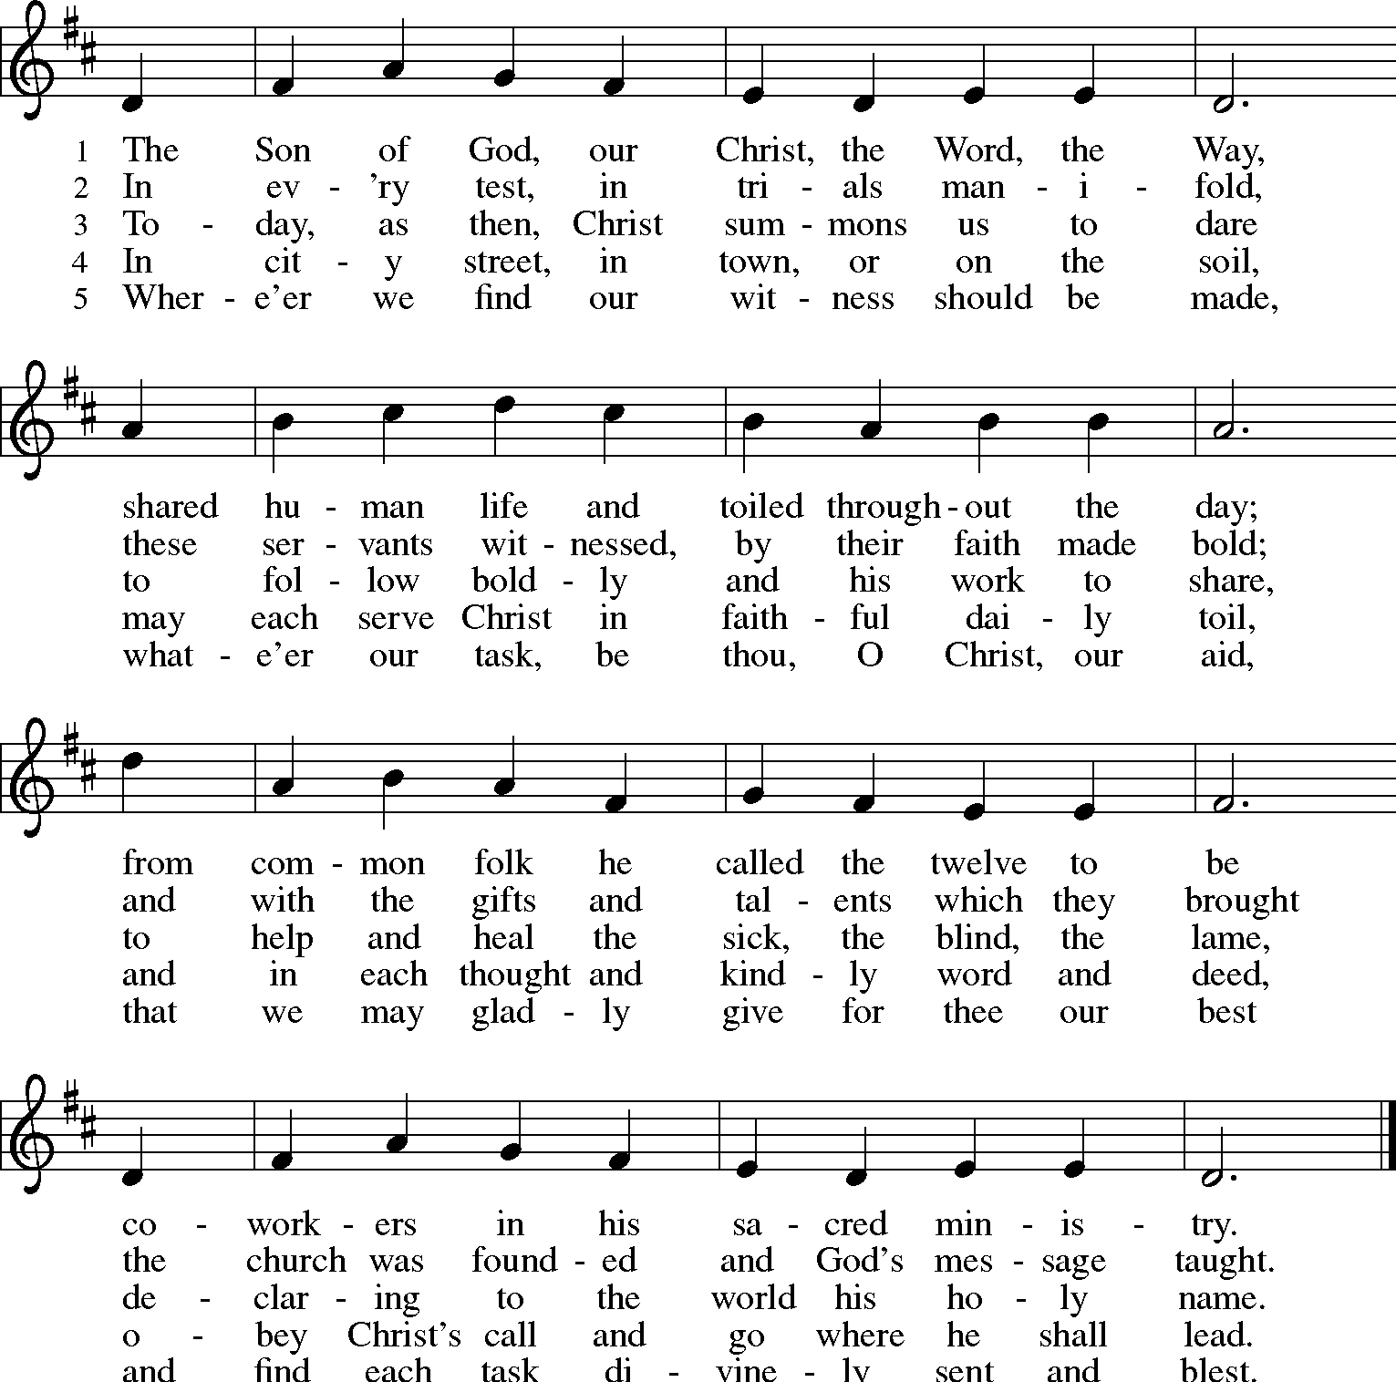

CREED
Let us confess our faith:

We believe in one God, the Father, the Almighty,
maker of heaven and earth,
of all that is, seen and unseen.

We believe in one Lord, Jesus Christ, the only Son of God,
eternally begotten of the Father, God from God, Light from Light, true God from true God, begotten, not made,
of one Being with the Father; through him all things were made.
For us and for our salvation he came down from heaven,
was incarnate of the Holy Spirit and the virgin Mary and became truly human.
For our sake he was crucified under Pontius Pilate; he suffered death and was buried.
On the third day he rose again
in accordance with the scriptures; he ascended into heaven
and is seated at the right hand of the Father.
He will come again in glory to judge the living and the dead, and his kingdom will have no end.

We believe in the Holy Spirit, the Lord, the giver of life, who proceeds from the Father,
who with the Father and the Son is worshiped and glorified, who has spoken through the prophets.
We believe in one holy catholic and apostolic church.
We acknowledge one baptism for the forgiveness of sins. We look for the resurrection of the dead,
and the life of the world to come. Amen.

PRAYERS OF INTERCESSION
With the whole people of God in Christ Jesus, let us pray for the church, those in need, and all of God’s creation.

For the church universal, its ministry, and the mission of the gospel; for our Synod with its gifts of diversity and passion for mission; for our Presiding Bishop Elizabeth Eaton, and our Interim Bishop, Donald McCoid; for the one who will become our next Bishop, that she or he may be a bridge to the wider church and a sign of our unity in Christ.
Hear us, O God.

Your mercy is great.

For your Spirit’s guidance and direction during this season of discernment, that our conversations may be holy and uplifting; for your leading of those who shall elect the next Bishop of our Synod, that we may receive an upright and faithful shepherd who will care for your people and encourage us for the mission we share.
Hear us, O God.

Your mercy is great.

For the well-being of creation, that our leaders would be courageous and bold in advocating for the healing of the natural world.
Hear us, O God.

Your mercy is great.

For peace and justice in the world, for the nations, for those in authority, and for our communities, that our leaders would be bold in their public witness for the healing of the nations.
Hear us, O God.

Your mercy is great.

For the poor, oppressed, sick, bereaved, lonely; for all who suffer in body, mind, or spirit; for our many local and synodical efforts to care for all in need.
Hear us, O God.

Your mercy is great.

For our congregations, and other local ministry settings; for our pastors, deacons, and lay leaders; for our synodical officers, for our Synod Council, for the committees charged with the implementation of our strategic plan, for all Synod committees and initiatives, [especially the ones we now name].
Hear us, O God.

Your mercy is great.

[Other intercessions may be invited]

For the faithful departed…. [including those who recently have died and those commemorated on the church’s calendar].
Hear us, O God.

Your mercy is great.

Into your hands, gracious God, we commend all for whom we pray, trusting in your mercy; through Jesus Christ, our Savior.

Amen.
PEACE
The peace of Christ be with you always.

And also with you.

MEAL
HYMN AT THE SETTING THE TABLE
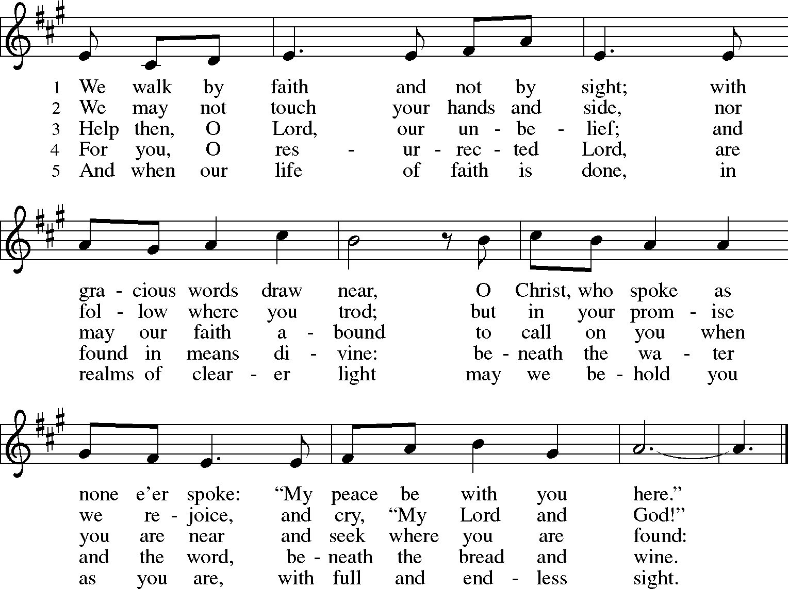

OFFERING PRAYER
Merciful God, as grains of wheat scattered upon the hills were gathered together to become one bread, so let your church be gathered together from the ends of the earth into your kingdom, for yours is the glory through Jesus Christ, now and forever.

Amen.
GREAT THANKSGIVING
The Lord be with you. And also with you. Lift up your hearts.

We lift them to the Lord.

Let us give thanks to the Lord our God.

It is right to give our thanks and praise.

It is indeed right, our duty and our joy, that we should at all times and in all places
give thanks and praise to you, almighty and merciful God, through our Savior Jesus Christ.
Fulfilling the promise of the resurrection, you pour out the fire of your Spirit,
uniting in one body people of every nation and tongue.
And so, with Mary Magdalene and Peter and all the witnesses of the resurrection, with earth and sea and all their creatures,
and with angels and archangels, cherubim and seraphim, we praise your name and join their unending hymn:

HOLY, HOLY, HOLY
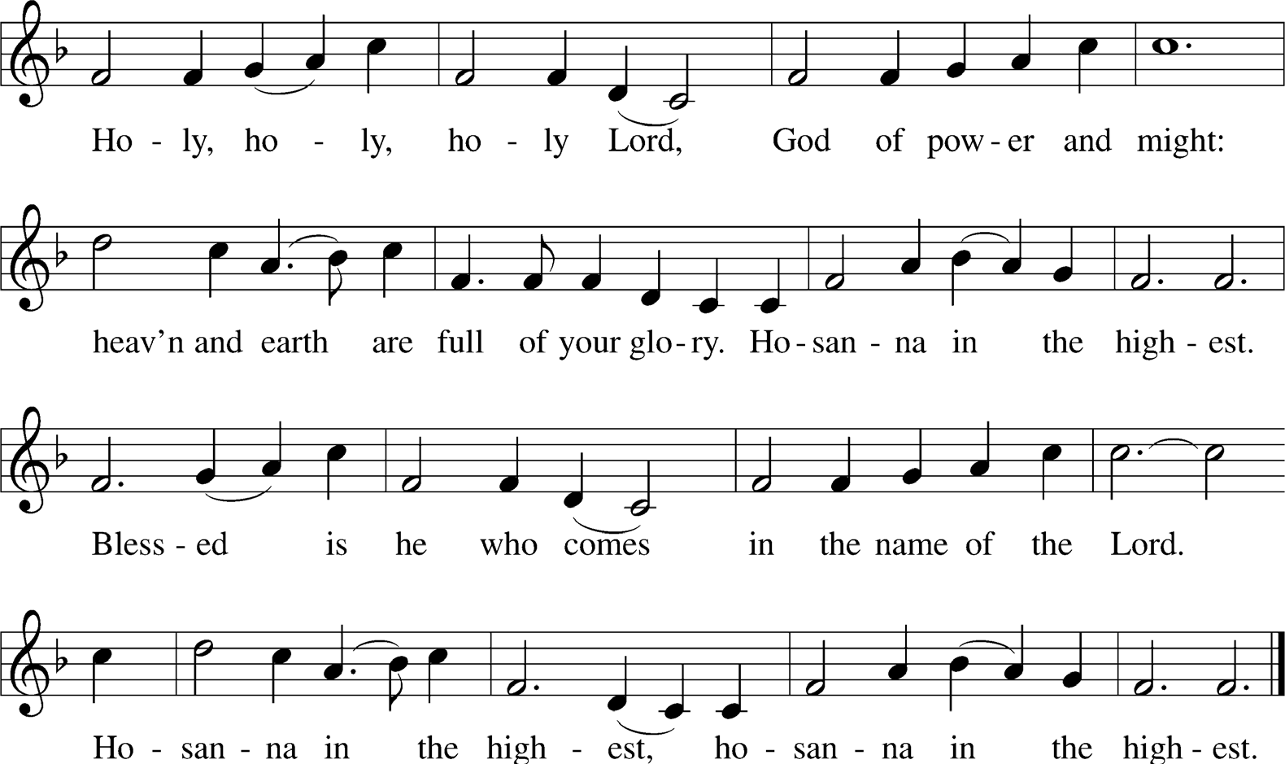

THANKSGIVING AT THE TABLE
Holy, mighty, and merciful Lord, heaven and earth are full of your glory.
In great love you sent to us Jesus, your Son, who reached out to heal the sick and suffering, who preached good news to the poor,
and who, on the cross, opened his arms to all.

In the night in which he was betrayed,
our Lord Jesus took bread, and gave thanks; broke it, and gave it to his disciples, saying:
Take and eat; this is my body, given for you. Do this for the remembrance of me.

Again, after supper, he took the cup, gave thanks, and gave it for all to drink, saying:
This cup is the new covenant in my blood,
shed for you and for all people for the forgiveness of sin. Do this for the remembrance of me.

Remembering, therefore, his death, resurrection, and ascension, we await his coming in glory.

Pour out upon us and upon these gifts the Spirit of your love, O Lord, and unite the wills of all who share this heavenly food,
the body and blood of Jesus Christ, our Lord; to whom, with you and the Holy Spirit,
be all honor and glory, now and forever.

Amen.

LORD’S PRAYER
Gathered into one by the Holy Spirit, let us pray as Jesus taught us.

Our Father in heaven, hallowed be your name, your kingdom come, your will be done,
on earth as in heaven.
Give us today our daily bread.
Forgive us our sins as we forgive those who sin against us.
Save us from the time of trial and deliver us from evil.
For the kingdom, the power, and the glory are yours, now and forever. Amen.

BREAKING OF BREAD AND INVITATION TO COMMUNION:
Taste and see that the Lord is good.

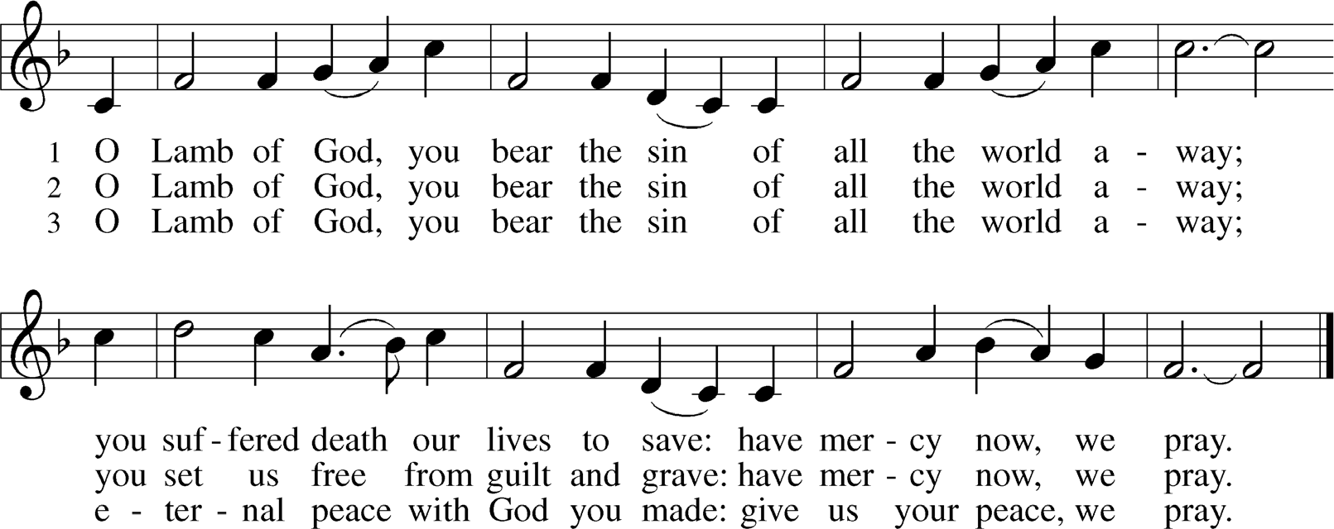
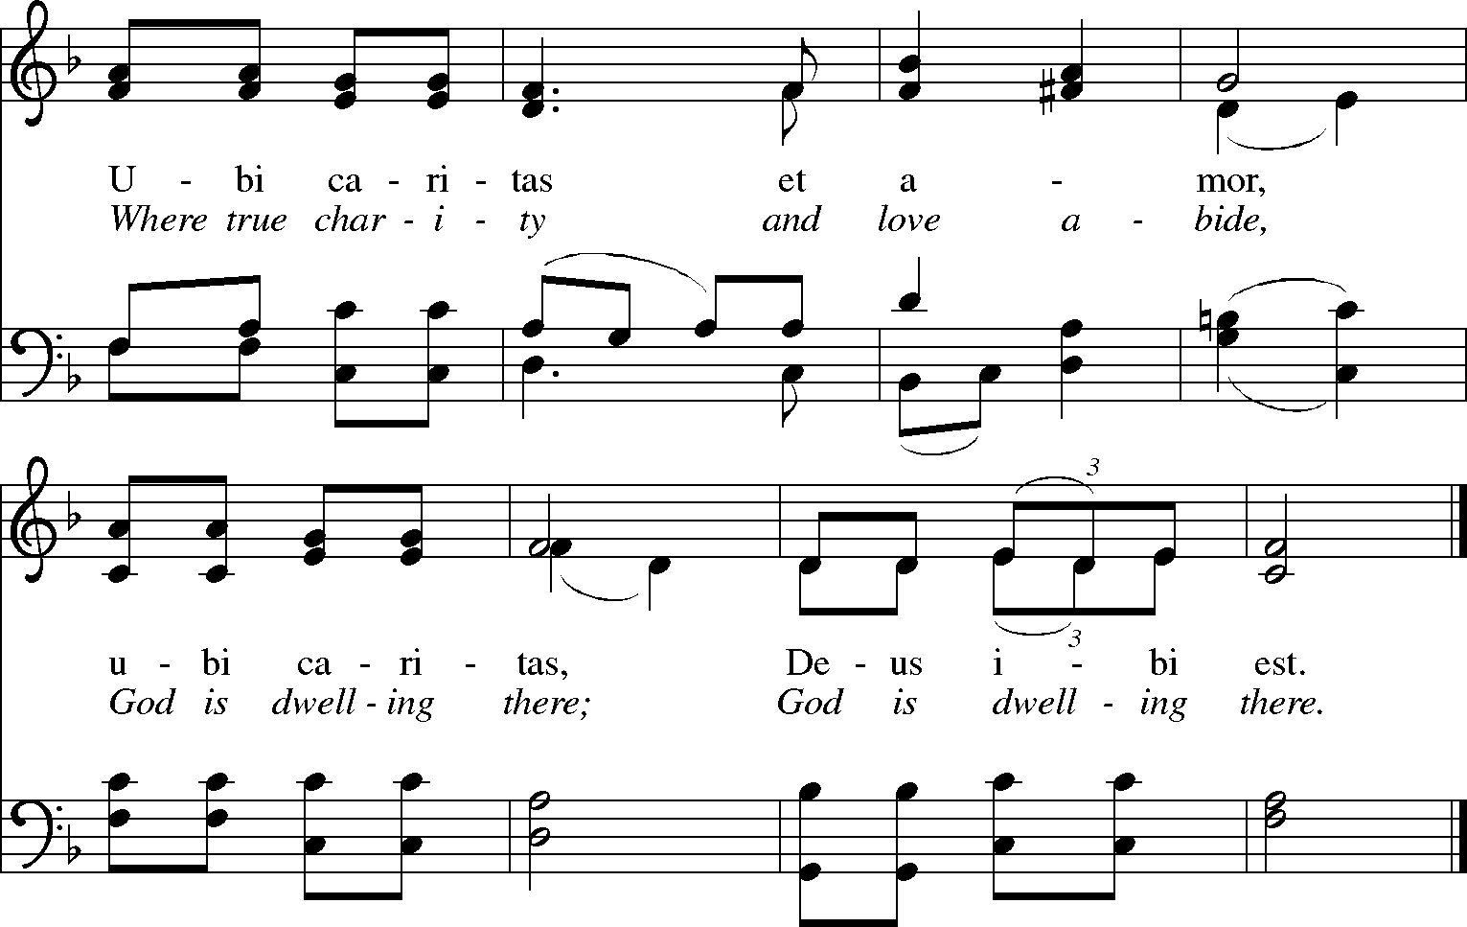
LAMB OF GOD AND COMMUNION SONG:

PRAYER AFTER COMMUNION
Let us pray.
God of abundance, with this bread of life and cup of salvation you have united us with Christ, making us one with all your people. Now send us forth in the power of your Spirit, that we may proclaim your redeeming love to the world and continue forever in the risen life of Jesus Christ, our Lord.

Amen.
SENDING
Sending Conversation

An extended conversation at the time of sending, building on our time of worship, prayer, and Bible Study, focuses on one or more of the following documents with discussion guided by the questions suggested, or other questions emerging from the local setting:
- Our Synod’s Ministry Site Profile.
  - What charisms/gifts, qualities, skills sets, personality, background, and experiences does our Synod Ministry Site Profile suggest that we need in a new Bishop?
  - What aspects of our Synod Ministry Site Profile are most important to you as you consider gifts and skills of a new Bishop?
- Our Synod Constitution’s chapter listing the duties of the Office of Bishop.
  - The listing of the responsibilities of a synodical bishop is exhaustive, if not to say exhausting. What duties of the
Bishop’s Office would you highlight as the most important for our Synod at this time?
- The Rite of Installation of a Bishop.
  - What charisms/gifts, qualities, skills sets, personality, background, and experiences do the prayers, readings, exhortations and other aspects of the Rite of Installation of a Bishop suggest that we need in a new Bishop?
After the conversation(s), the liturgy concludes with the Affirmation of Christian Vocation, Blessing, Song, and Dismissal.

AFFIRMATION OF CHRISTIAN VOCATION
Sisters and brothers, both your work and your rest are in God. Will you endeavor to pattern your life on the Lord Jesus Christ, in gratitude to God and in service to others, at morning and evening, at work and at play, all the days of your life?

I will, and I ask God to help me.

Almighty God, by the power of the Spirit you have knit these your servants into the one body of your Son, Jesus Christ. Look with favor upon them in their commitment to serve in Christ’s name. Give them courage, patience, and vision; and strengthen us all in our Christian vocation of witness to the world and of service to others; may your Holy Spirit lead and guide this season of discernment, as we prepare to elect a new Bishop; through Jesus Christ our Lord.

Amen.
BLESSING
The Lord bless you and keep you.
The Lord’s face shine on you with grace and mercy.
The Lord look upon you with favor and  give you peace.

Amen.
SENDING SONG
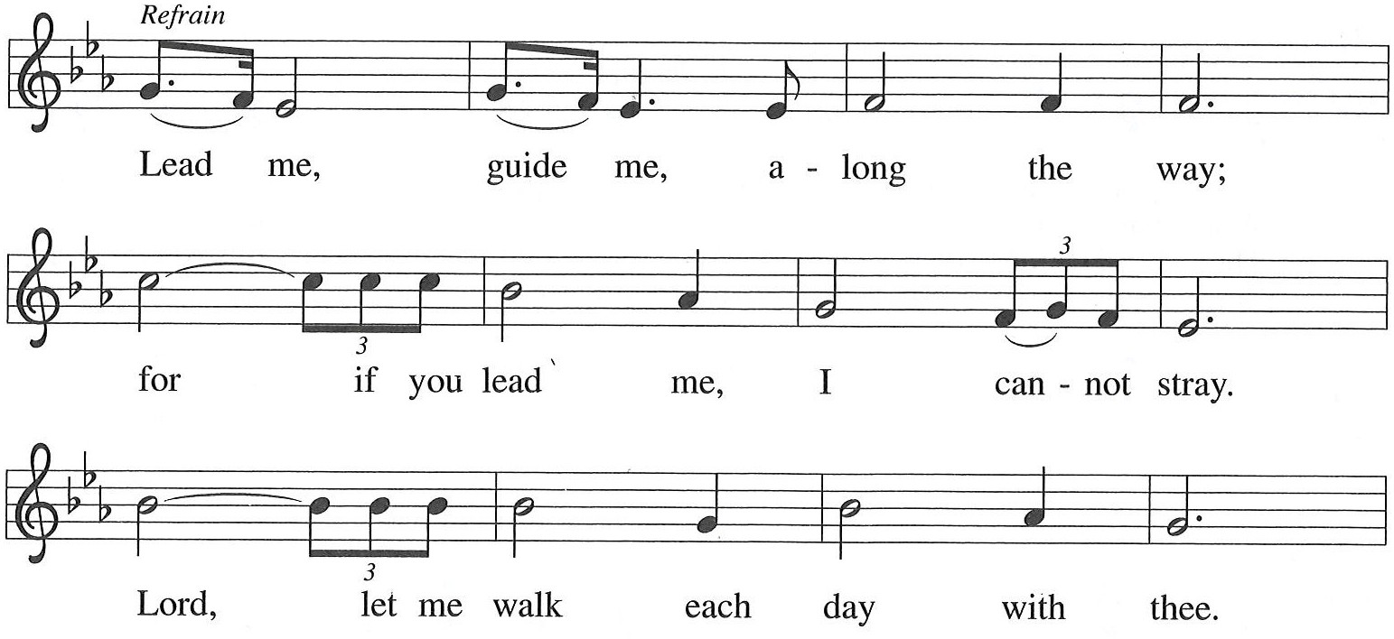

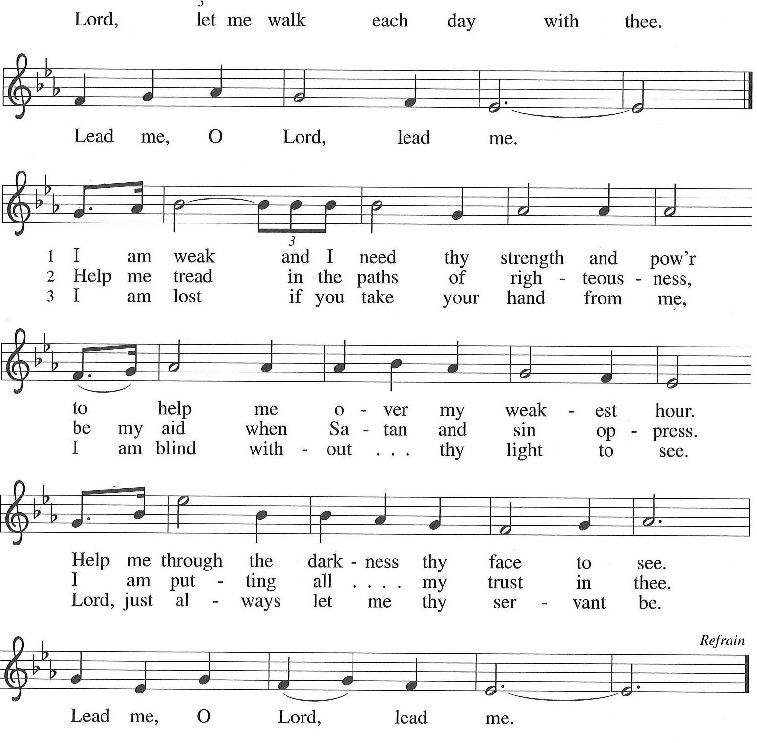

DISMISSAL
Go in peace. Christ is with you. Thanks be to God.

From sundaysandseasons.com. Copyright © 2018 Augsburg Fortress. All rights reserved. Reprinted by permission under Augsburg Fortress Liturgies Annual License #12366-S

