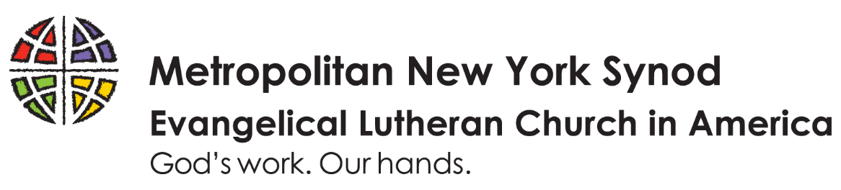
Fiscal Year 2022 MISSION SUPPORT COMMITMENT
for synod & churchwide ministries

Congregation: ___________________________________________________________

Address: _____________________ City: _______________________ Zip Code: ____

With thanksgiving to God, we estimate our mission support for the work of the wider church in Fiscal Year 2022 [February 1, 2021 – January 31, 2022] to be: $__________________. This represents % of our non-restricted receipts.

We plan on submitting our mission support:
_____ Monthly _____ Quarterly _____Semi-Annually _____Annually

If special circumstances will affect your mission support, please contact they synod office. Mission support from all, including subsidized congregations, is a sign of out partnership in the Gospel.
In Fiscal Year 2022, the Metropolitan New York Synod will give 53% of what it receives to ELCA - Churchwide ministry, which supports new congregations, missionaries, seminaries, colleges and universities, campus ministries, early childhood centers, elementary schools, outdoor ministries, social ministry organizations, advocacy, and community development on a national scale. Partnership dollars come back to synods and congregations in the way of grants, services, programs, staff and resources.

Pastor's Name: ___________________________E-Mail: _______________________________
Treasurer's Name: ___________ __ E-Mail: ________________________________
Phone Number: ____________________________

Please complete this form, save a copy for your records, and return it to the synod office by February 7. The form can be downloaded from www.mnys.org/giving/mission_support.

Thank you!

How to submit:
- Download and save this fillable form to your computer.
- Complete the form and save your changes.
- E-mail completed form as an attachment to annualreports@mnys.org or mail to:
Metropolitan New York Synod
475 Riverside Drive, Suite 1620
New York, NY 10115

