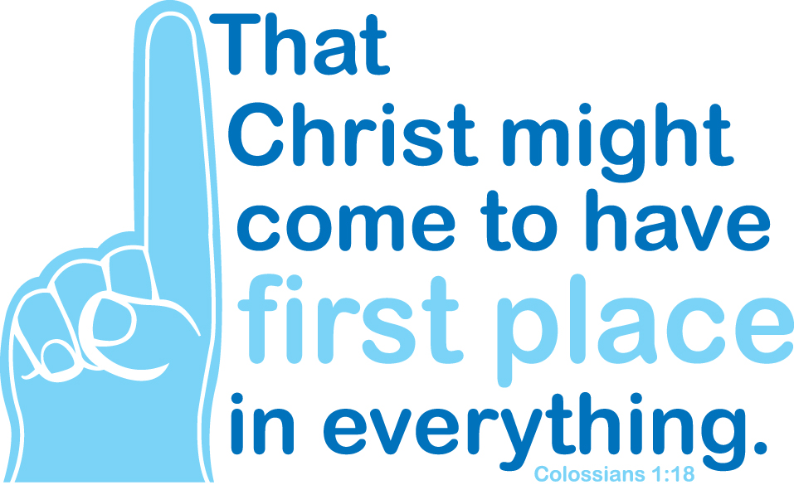

He is the image of the invisible God, the firstborn of all creation; for in him all things in heaven and on earth were created, things visible and invisible, whether thrones or dominions or rulers or powers—all things have been created through him and for him. He himself is before all things, and in him all things hold together. He is the head of the body, the church; he is the beginning, the firstborn from the dead, so that he might come to have first place in everything. (Colossians 1:15-18)

Dear Brothers and Sisters in Christ,

Every day we are faced with numerous images and claims of authority over us. As Christians we must discern those claims and make choices. What’s important to us? How will we live? What place does God take in the many priorities we set before ourselves? How we answer these questions has a huge impact on how we will live out a life of commitment to our Lord Jesus, who has given us everything.

One way Christians respond to Jesus’ incredible love is through generous giving and living. Through our stewardship of what God is doing in our lives, we give thanks by offering monetary support, as well as our time and talents, to grow Christ’s mission and ministry lived out in our congregation and wider church.

To help us grow in our faith and commitment to Christ we are participating with other congregations in a stewardship emphasis the month of November. Each week, for three weeks, we invite you to gather with others around God’s word and conversation in a spiritual formation group for one hour. Sign up at the church or by email __________. Each Sunday a member of our congregation will share a “mission moment” as to what God is doing in their life through the ministry of our congregation and on Christ the King Sunday, November 20 at our worship services Pastor ____________ from __________Church will be our preacher and worship leader in a pulpit exchange with ___________Church. Together we hope to share a message of God’s abundance and our commitment to greater service and generosity to Christ and his church.

I hope you will be a part of this opportunity to pray, talk, worship, and give.

Yours in Christ,

November 6, 2016

Dear Brothers and Sisters in Christ,

November 20th is Christ the King Sunday. This year we are participating in a synod-wide stewardship emphasis and working with __________ Church. On that Sunday we will have as our worship leader and preacher Pastor ________ as I lead worship and preach at ___________ Church. Together we hope to share a message of God’s abundance and our commitment to greater service and generosity to Christ and his church.

To prepare us for that Sunday I have included information to help you in your discernment leading up to Christ the King. The first is a narrative budget that gives you a sense of what we do with the money that is given each and every Sunday and the impact that it has on lives. The second is the tool for reflecting on your own level of giving and an invitation to grow as we seek to serve Christ in mission.

Please be sure to welcome Pastor _______ and thank him/her for his/her partnership in the gospel with us.

Yours in Christ,

Att: Narrative Budget
Giving Worksheet

November 20, 2016

Dear ________,

Thank you very much for your participation in the Christ the King Commitment Service. Thank you for your commitment to the ministry and mission of _______________ Church. We hope to accomplish a lot this year and we are blessed by dedicated followers of Jesus like yourself.

If at any time you need to change your commitment during the year just let me know.

Again, thank you so much.

Yours in Christ,

Financial Secretary

Commitment for 2017:

______________% $_______________ per week / per month / yearly

