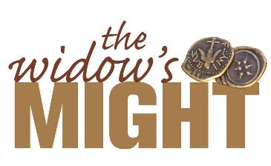

Worship Resources

Hymn & Song Suggestions
Awesome God W&P 13
Lord, I lift your name on high ELW 857
Praise and thanksgiving ELW 409/LBW 689
For the fruit of all creation ELW 679/WOV 760
We are an offering ELW 692
Take my life (Patmos) ELW 685/LBW 406
Take my life (Toma mi volundad) ELW 583

Confession and Forgiveness
In the name of the Father and of the  Son and of the Holy Spirit.
Amen.
Christ is our high priest,
who offered himself as the perfect sacrifice for our sins.
All are invited to freely offer themselves to his healing and release.
Mighty God,
We come to your holy temple
to give you all that we are.
Forgive us our sins, make us whole,
and restore our lives, so that we might worship you
and serve our neighbor.
Amen.
Christ, having been offered once to bear the sins of many, will save those who eagerly wait for him. Almighty God, Father,  Son, and Holy Spirit grant you forgiveness of all your sins.
Amen.

Prayer of the Day (ELW)
O God, you show forth your almighty power
chiefly by reaching out to us in mercy.
Grant us the fullness of your grace,
strengthen our trust in your promises,
and bring all the world to share in the treasures that come through your Son, Jesus Christ, our Savior and Lord. Amen.

Post Communion Prayer
Creator God, who made heaven and earth, the seas, and all that is in them; You keep your promises forever, give justice to those who are oppressed, and food to those who hunger. Thank you for your abundance and give us what we need to be your faithful servants. In Jesus’ name we pray. Amen.

Benediction (from Psalm 46)
Happy are they who have the God of Jacob for their help,
whose hope is in the LORD their God.
May Almighty God, Father, Son, and Holy Spirit
bless you with the knowledge of his abundant love for you. Amen.

