The First Sunday in Lent ________ ___ March 9, 2025

These forty days called Lent are like no other. It is our opportune time to return to the God who rescues, to receive the gifts of God’s grace, to believe with the heart and confess with the mouth the wonder of God’s love in Jesus, and to resist temptation at every turn. This is no small pilgrimage on which we have just embarked. It is a struggle Jesus knew. It is a struggle Jesus shares. The nearness of the Lord, in bread and wine, water and word, will uphold and sustain us.
GATHERING - The Holy Spirit calls us together as the people of God.

QUIET MEDITATION & PRELUDE
WELCOME
Please stand as you are able.
CONFESSION and FORGIVENESS
All may make the sign of the cross, the sign that is marked at baptism, as the presiding minister begins.
Blessed be the holy Trinity, ☩ one God,
who forgives all our sin,
whose mercy endures forever.
Amen.
Let us return to God, confessing our sin in the assurance of God’s abiding love.
Silence is kept for reflection.
Compassionate One,
you are slow to anger and abounding in steadfast love,
but our lives do not always reflect you
and your love for the world.
We do not show others the tender compassion
you have shown to us.
We do not welcome others with the radical hospitality
you grant to all people.
We oppress others,
even though you have set us free again and again.
We squander the abundant gifts of the earth.
Transform our lives
and guide us again in the way of the cross.
Amen.
Beloved in Christ,
God’s arms are always stretched open wide
to welcome the wandering ones home.
In ☩ Christ your sins are forgiven.
You have a place in God’s house forever.
Amen.

Gathering HYMN My Hope Is Built on Nothing Less ELW 596
APOSTOLIC GREETING
The grace of our Lord Jesus Christ, the love of God, and the communion of the Holy Spirit be with you all.
And also with you.

KYRIE
In peace, let us pray to the Lord.
Lord, have mercy.
For the peace from above,
and for our salvation,
let us pray to the Lord.
Lord, have mercy.
For the peace of the whole world,
for the well-being of the Church of God,
and for the unity of all,
let us pray to the Lord.
Lord, have mercy.
For this holy house,
and for all who offer here their worship and praise,
let us pray to the Lord.
Lord, have mercy.
Help, save, comfort, and defend us, gracious Lord.
Amen.

Prayer of the Day
O Lord God, you led your people through the wilderness and brought them to the promised land. Guide us now, so that, following your Son, we may walk safely through the wilderness of this world toward the life you alone can give, through Jesus Christ, our Savior and Lord, who lives and reigns with you and the Holy Spirit, one God, now and forever. Amen.

Please be seated.

WORD - God speaks to us in scripture reading, preaching, and song.

FIRST READING: Deuteronomy 26:1-11
¹ “When you have come into the land that the Lord your God is giving you as an inheritance to possess and you possess it and settle in it, ² you shall take some of the first of all the fruit of the ground, which you harvest from the land that the Lord your God is giving you, and you shall put it in a basket and go to the place that the Lord your God will choose as a dwelling for his name. ³ You shall go to the priest who is in office at that time and say to him, ‘Today I declare to the Lord your God that I have come into the land that the Lord swore to our ancestors to give us.’ ⁴ When the priest takes the basket from your hand and sets it down before the altar of the Lord your God, ⁵ you shall make this response before the Lord your God: ‘A wandering Aramean was my ancestor; he went down into Egypt and lived there as an alien, few in number, and there he became a great nation, mighty and populous. ⁶ When the Egyptians treated us harshly and afflicted us, by imposing hard labor on us, ⁷ we cried to the Lord, the God of our ancestors; the Lord heard our voice and saw our affliction, our toil, and our oppression. ⁸ The Lord brought us out of Egypt with a mighty hand and an outstretched arm, with a terrifying display of power, and with signs and wonders; ⁹ and he brought us into this place and gave us this land, a land flowing with milk and honey. ¹⁰ So now I bring the first of the fruit of the ground that you, O Lord, have given me.’ You shall set it down before the Lord your God and bow down before the Lord your God. ¹¹ Then you, together with the Levites and the aliens who reside among you, shall celebrate with all the bounty that the Lord your God has given to you and to your house.”
The word of the Lord. Thanks be to God.

PSALM: Psalm 91:1-2, 9-16 read responsively
¹ You who dwell in the shelter of| the Most High,
who abide in the shadow of the Almighty
² you will say to the Lord, “My refuge and my stronghold,
my God in whom I put my trust.”
⁹ Because you have made the Lord your refuge,
and the Most High your habitation,
¹⁰ no evil will befall you,
nor shall affliction come near your dwelling.
¹¹ For God will give the angels charge over you,
to guard you in all your ways.
¹² Upon their hands they will bear you up,
lest you strike your foot against a stone.
¹³ You will tread upon the lion cub and viper;
you will trample down the lion and the serpent.
¹⁴ I will deliver those who cling to me;
I will uphold them, because they know my name.
¹⁵ They will call me, and I will answer them;
I will be with them in trouble; I will rescue and honor them.
¹⁶ With long life will I satisfy them,
and show them my salvation.

SECOND READING: Romans 10:8b-13
^{8b} “The word is near you,
in your mouth and in your heart”
(that is, the word of faith that we proclaim), ⁹ because if you confess with your mouth that Jesus is Lord and believe in your heart that God raised him from the dead, you will be saved. ¹⁰ For one believes with the heart, leading to righteousness, and one confesses with the mouth, leading to salvation. ¹¹ The scripture says, “No one who believes in him will be put to shame.” ¹² For there is no distinction between Jew and Greek; the same Lord is Lord of all and is generous to all who call on him. ¹³ For “everyone who calls on the name of the Lord shall be saved.”
The word of the Lord. Thanks be to God.

GOSPEL ACCLAMATION
Please stand as you are able.

The GOSPEL: LUKE 4: 1-13
The holy gospel according to Luke, the 4th chapter
Glory to you, O Lord.
¹ Jesus, full of the Holy Spirit, returned from the Jordan and was led by the Spirit in the wilderness, ² where for forty days he was tested by the devil. He ate nothing at all during those days, and when they were over he was famished. ³ The devil said to him, “If you are the Son of God, command this stone to become a loaf of bread.” ⁴ Jesus answered him, “It is written, ‘One does not live by bread alone.’ ”
⁵ Then the devil led him up and showed him in an instant all the kingdoms of the world. ⁶ And the devil said to him, “To you I will give all this authority and their glory, for it has been given over to me, and I give it to anyone I please. ⁷ If you, then, will worship me, it will all be yours.” ⁸ Jesus answered him, “It is written,
‘Worship the Lord your God,
and serve only him.’ ”
⁹ Then the devil led him to Jerusalem and placed him on the pinnacle of the temple and said to him, “If you are the Son of God, throw yourself down from here, ¹⁰ for it is written,
‘He will command his angels concerning you,
to protect you,’
¹¹ and
‘On their hands they will bear you up,
so that you will not dash your foot against a stone.’ ”
¹² Jesus answered him, “It is said, ‘Do not put the Lord your God to the test.’ ” ¹³ When the devil had finished every test, he departed from him until an opportune time.
The gospel of the Lord. Praise to you, O Christ.
Please be seated.

SERMON

Please stand as you are able.
Hymn of the Day The Glory of These Forty Days ELW 320
APOSTLES CREED
I believe in God, the Father almighty,
creator of heaven and earth.
I believe in Jesus Christ, God’s only Son, our Lord,
who was conceived by the Holy Spirit,
born of the virgin Mary,
suffered under Pontius Pilate,
was crucified, died, and was buried;
he descended to the dead.*
On the third day he rose again;
he ascended into heaven,
he is seated at the right hand of the Father,
and he will come to judge the living and the dead.
I believe in the Holy Spirit,
the holy catholic church,
the communion of saints,
the forgiveness of sins,
the resurrection of the body,
and the life everlasting. Amen.

Prayers of THE CHURCH (assisting minister)
A Led by the Spirit, let us turn to God in prayer for the church, the world, and all those in need.
A brief silence.
Gracious God, speak your word anew among your church. Strengthen it to withstand the temptation to turn inward in fear or complacency. Embolden church institutions to turn from self-preservation toward the self-giving love of Jesus. God, in your mercy,
receive our prayer.
Mothering God, speak the word of life into wilderness places and fertile fields. Grant wisdom to your people, that we may stop the urge to strip the land of resources and instead preserve the natural world for future generations. God, in your mercy,
receive our prayer.
Almighty God, speak a word of wisdom to people in positions of power: mayors, councils, and tribal leaders, legislators, judges and juries, presidents, and monarchs. Help them discern your voice and follow your guidance, resisting the temptations of the evil one. God, in your mercy,
receive our prayer.
Steadfast God, speak words of courage to your people in the wilderness. Protect migrants and refugees on perilous journeys, that they find safe refuge and a portion in the bounty you have given humanity to share. God, in your mercy,
receive our prayer.
Loving God, speak gently to all who are alone. Bless all who attend to those who are overlooked, vulnerable, or lonely, that all find belonging in your love. We pray for all who are ill. God, in your mercy,
receive our prayer.
Living God, we give thanks for all the faithful who have crossed the threshold from death to life. Guide us who are living to learn from their wisdom and follow their example. God, in your mercy,
receive our prayer.
P - Receive the prayers of your people and draw all things together in your love, in the name of Jesus, who leads us from death to life.
Amen.

Peace
The peace of Christ be with you always.
And also with you.

Please be seated after sharing the peace.

Offering & CHOIR ANTHEM
An offering is gathered for the mission of the church, including the care of those in need.
Please stand as you are able.

OFFERING SONG
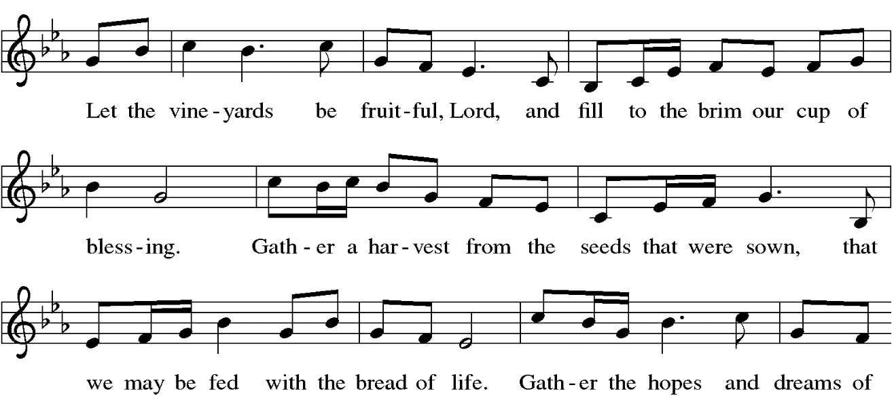
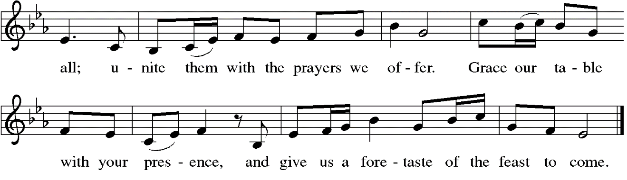

Offering Prayer (assisting minister)
A - Gracious Provider,
you set your immense treasures among us,
opening your heart to the world.
As we prepare to feast on your bountiful love,
deepen our commitment to sharing those
treasures with others,
through our Savior, Jesus Christ. Amen.

MEAL - God feeds us with the presence of Jesus Christ.

GREAT THANKSGIVING
The Lord be with you.
And also with you.

Lift up your hearts.
We lift them to the Lord.

Let us give thanks to the Lord our God.
It is right to give our thanks and praise.

PREFACE
It is indeed right, our duty and our joy,
that we should at all times and in all places
give thanks and praise to you, almighty and merciful God,
through our Savior Jesus Christ.
You call your people to cleanse their hearts
and prepare with joy for the paschal feast,
that, renewed in the gift of baptism,
we may come to the fullness of your grace.
And so, with all the choirs of angels,
with the church on earth and the hosts of heaven,
we praise your name and join their unending hymn:

THANKSGIVING AT THE TABLE
You are indeed holy, almighty and merciful God.
You are most holy,
and great is the majesty of your glory.

You so loved the world that you gave your only Son,
so that everyone who believes in him may not perish
but have eternal life.

We give you thanks for his coming into the world
to fulfill for us your holy will
and to accomplish all things for our salvation.

In the night in which he was betrayed,
our Lord Jesus took bread, and gave thanks;
broke it, and gave it to his disciples, saying:
Take and eat; this is my body, given for you.
Do this for the remembrance of me.

Again, after supper, he took the cup, gave thanks,
and gave it for all to drink, saying:
This cup is the new covenant in my blood,
shed for you and for all people for the forgiveness of sin.
Do this for the remembrance of me.

Remembering, therefore, his salutary command,
his life-giving passion and death, his glorious resurrection and ascension,
and the promise of his coming again,
we give thanks to you, O Lord God Almighty,
not as we ought but as we are able;
we ask you mercifully to accept our praise and thanksgiving
and with your Word and Holy Spirit to bless us, your servants,
and these your own gifts of bread and wine,
so that we and all who share in the body and blood of Christ
may be filled with heavenly blessing and grace,
and, receiving the forgiveness of sin,
may be formed to live as your holy people
and be given our inheritance with all your saints.

To you, O God, Father, Son, and Holy Spirit,
be all honor and glory in your holy church, now and forever.
Amen.

Lord's Prayer
Gathered into one by the Holy Spirit, let us pray as Jesus taught us.
Our Father, who art in heaven, hallowed be thy name, thy kingdom come, thy will be done, on earth as it is in heaven. Give us this day our daily bread; and forgive us our trespasses, as we forgive those who trespass against us; and lead us not into temptation but deliver us from evil. For thine is the kingdom, and the power, and the glory, forever and ever. Amen.

INVITATION TO COMMUNION
All who are hungry, come! The feast of grace is spread.

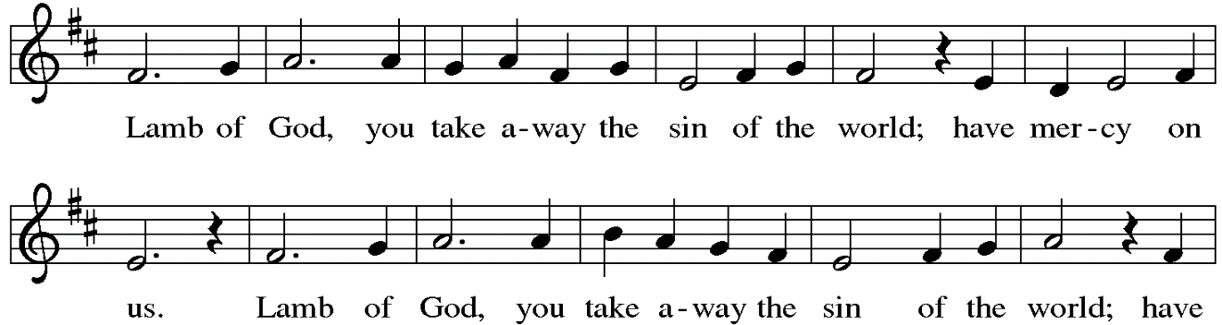
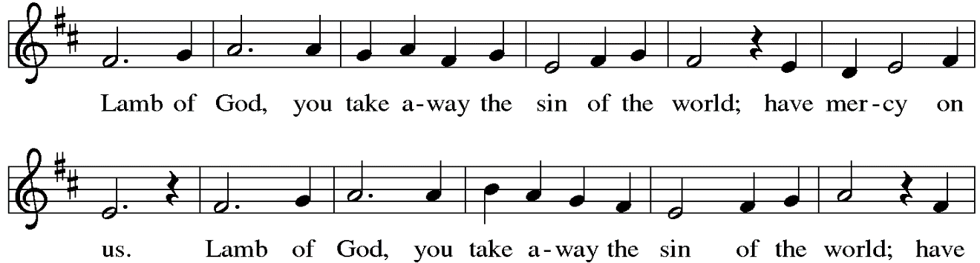
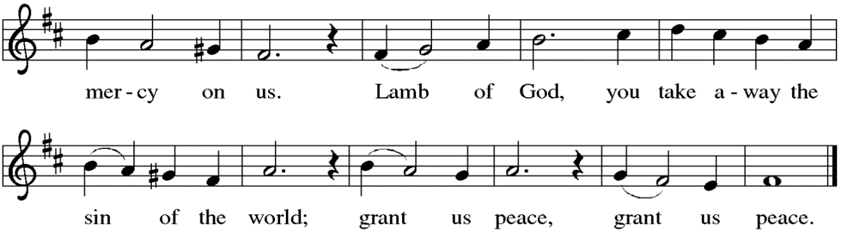
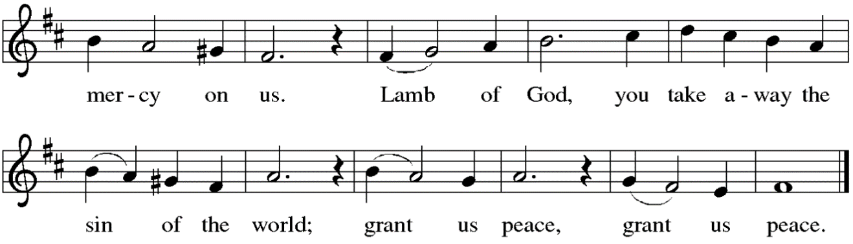

Please be seated.
distribution of the sacrament
All Christians baptized in the name of The Holy Trinity and who believe by faith that the elements of bread and wine are the true body and blood of Christ are invited to commune. Gluten-free wafers are available as an alternative. All may come forward for God’s blessing.

Please stand as you are able.
Table Blessing
BLESSING
May the body and blood of our Lord Jesus Christ strengthen you and keep you in His
grace.
P - May the body and blood of our Lord Jesus Christ strengthen you and keep you in His grace. Amen.

Prayer after Communion (assisting minister)
A - Generous Host,
you have shared your feast with us and made us new.
Send us now to set tables of love and grace in our communities,
that your liberating love might nourish the world into freedom,
in the name of the crucified one, Jesus Christ our Lord.
Amen.

SENDING
BENEDICTION
P God, the giver of love, ☩ Christ, the resurrection and the life,
and the Holy Spirit of rebirth bless you in this Lenten journey. Amen.

Sending hymn Blest Be the Tie that Binds ELW 656
Dismissal (assisting minister)
A - Go in peace. Care for others as God cares for you.
Thanks be to God.
Soli Deo Gloria!

